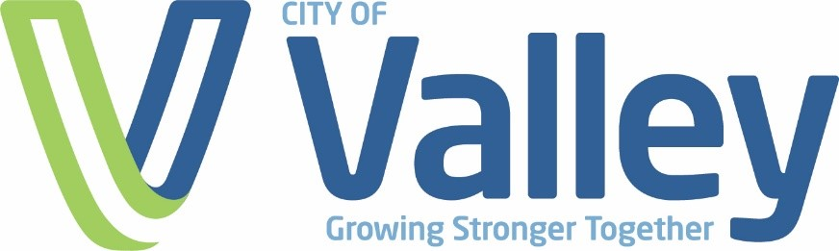

**MEMBERSHIPS PAID ANNUALLY TO ANY**

**ASSOCIATION OR ORGANIZATION**

|  |  |
| --- | --- |
| **Association/Organization** | **Dues** |
| Nebraska Library Association | $60.00 |
| American Library Association | $125.00 |
| Association of Rural and Small Libraries | $75.00 |
| Arbor Day Foundation | $20.00 |
| Nebraska Rural Water Association | $450.00 |
| Nebraska Water Resources Association | $105.00 |
| International Code Council | $170.00 |
| National League of Cities | $924.00 |
| League of Nebraska Municipalities – Utilities membership | $1,112.00 |
| League of Nebraska Municipalities | $29,736.00 |
| International Institute of Municipal Clerks | $195.00 |
| Nebraska Municipal Clerks Association | $100.00 |
| Three Rivers Clerks Association | $10.00 |
| Mid-States Organized Crime Information Center | $100.00 |
| Police Chiefs Association of Nebraska | $120.00 |
| Nebraska City/County Management Association | $480.00 |